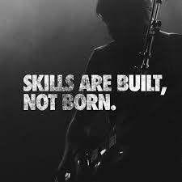

**Interpersonal Skills**

Required During an open day

Name – Aaron. M | HND Unit-3 | Date – 28/09/18 | Teacher- Kam Baht

# **What’s the Purpose?**

The purpose of this report is to evaluate the effectiveness and application of interpersonal skills during the planning and design of an open day. Some of these type of skills include:-

* Communication
* Planning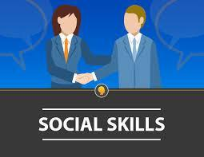
* Time Management
* Efficiency
* Persistency
* Understanding
* Decision Making
* Responsibility
* Motivation
* Active listening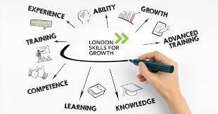
* Caring
* Leadership
* Teamwork
* Creativity
* Coaching and Mentoring
* Personal Development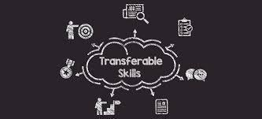
* Empathy
* Management
* Ideas
* Solution
* Education

Therefore interpersonal skills are essential in effective planning as it involves all the skills above.

## **What are Interpersonal Skills and its applications**?

* Interpersonal skills are soft skills for personal effectiveness that help working with others and take initiative and also have negotiating skills, assertiveness skills and social skills.
* People with these skills tend to be more productive in groups, they also communicate efficiently with family, friends and co-workers.

*"Interpersonal skills are the skills we use every day when we communicate and interact with other people, both individually and in groups."  
  
"People with strong interpersonal skills are often more successful in both their professional and personal lives."  
  
Read more at: https://www.skillsyouneed.com/interpersonal-skills.html*



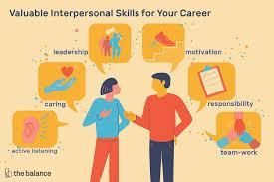

## **What are the types of Interpersonal Skills required during an open day** ?

Interpersonal skills which are required during an open day are as follows:

* **Communication skills:**
* **Verbal Communication –** what we say and how it’s said.
* **NON – Communication –** Body language and tone of voice.
* **Listening Skills –** how to understand verbal and non-verbal message by others.
* **Emotional intelligence - Able** to understand your emotions as well as others.
* **Team-working -** Able to work with others in groups and teams.
* **Negotiation, persuasion and influencing skills –** working to find a mutual agreement with others.
* **Conflict resolution and mediation –** working with others to resolve problems and disagreements in a positive way.
* **Problem solving and decision making - working** with others to identify and solve problems to make the best decision.

*Read more at: https://www.skillsyouneed.com/interpersonal-skills.html*

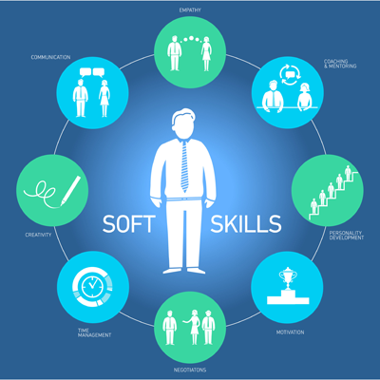

## 

## **How these skills benefit during an open day?**

As we have seen what essential skills are required when designing an open day we also need to know how it benefits us in the process of designing an open day.

* **Communication skills:**
* **Verbal Communication –**

When we speak we must not hesitate in saying what we want to convey to others, to get the point across. We should also maintain confidentiality with our employees and not use offensive or disrespectful language as it maintains equality for everyone.

* **NON – Communication –**

Our body language says it all, the way we walk, talk, and speak to others .This is especially useful as it make us be more professional and people look up to us and make working efficient.

* **Listening Skills –**

Helps to understand both verbal as well as nonverbal communication with others. .It is very important to consider others opinion and a decision where everyone is happy with and speak about anything which doesn't add up.

* **Emotional intelligence -**

To understand others emotions you’ll need to master one emotion, it can be difficult to show one's emotion to others especially during a working environment and seek help for it, by reflecting on one’s emotions we can help other need.

* **Team-working -**

Team make the dream work, this is true when we work out our difficulties with our teammates and find a common idea which work to move forward. Working together is the most important skill that helps us get things done quickly.

* **Negotiation, persuasion and influencing skills –**

If you don’t like the way things are stand up and persuade by giving reasons to .support you point. This benefits everyone in turn and make for a better environment for everyone. This helps you to build connections and strengthen your skill.

* **Conflict resolution and mediation –**

IT is not always easy to put your point of view in front of others without facing consequences in a positive way . Its is always best to back up your view by give the outcomes and speaking about how to deal with problems without creating any arguments.

* **Problem solving and decision making -**

Problems can only be solved be working .together to make the right decision for everyone by speaking with one and other by discussing with teams. Decisions can be difficult to make but by taking everyone’s advice this can be easily managed.

During an open day these skills really come in handy and make things easier to handle and efficiently help in planning and deciding what to do and what not to, By following these simple strategies and acquiring this skill it benefits us in making the right calls and over all makes designing an open days more organized and clear.

By making and distributing leaflets which contain these values and creating a schedule for everyone to follow which is effective in demonstrating time management which is a key part of planning any event by also providing notes which give extra information about the place, time, and directions to a specific event.

Organizing what's going to happen during the period of time and prioritising workloads and setting objectives to employees by using time effectively and also making and keeping appointments for any queries or doubts thats needs to be discussed. Planning and scheduling tasks and activities for the future.

Designing a schedule for different departments in charge of security, decorations, volunteering, cafeteria, designer, stalls, It support, janitor timings, student administrative, student advisors, transport services,etc. and allot different times to prepare for the open day.

Different computing departments will have various talks for students and their parents during the open day and timings for talks will also be available along with the schedule as well as appointments timings will be mentioned .

## **How to improve these skills?**

Now a days , people assume that one can only be born with interpersonal skills and acquire all the knowledge required to be successful. But in fact it requires time and effort from an early age, and when it's time to seek for a job, people want to learn these skills to get promotions and make themselves the most worthy member to the whole company. “Practice makes perfect” as they say, by practicing how to express appreciation to the members of staff, practicing to empathise for others, when there are disputes between each other it must quickly settle before things get worse. “Communication is key” without it things get buried beneath the surface and what needs to be said doesn’t happen and then things go wrong at the end without planning them accordingly. We also need to listen what others need to say as everyone has a say in the matter and learn new things as well, so that when its needs explaining again it will be easier to say it back to others and communication will be established with everyone.

## **How these skills benefit Staff members ?**

When these skills are used they make it easier for others to understand, communication becomes efficient and effective. Giving them feedback on their performance and correcting them if any error or difficulties are faced by them. By teaching them how to go through their tasks and learning from their mistakes communication is taking place in between, if they have their own views and want to express it then it helps them to do so as there is negotiation taking place so the right decision can be made. Staffs can open up to you and elaborate on their situation and express themselves. They also will be motivated to work with passion. During an open day it will make them come forward to you and communicate about the designing, planning and organising schemes that will make it reliable to implement. Staff could go about with their works as they have been properly briefed about the goal by working together as a team. They bring together the whole management to strive while taking support from one and other and go beyond working in their area of knowledge and might even take up the lead when necessary and work for greater good of the organisation. An organisation is made of people and your interpersonal skills can be greatly improved just by getting along with people and living your life with a sense of purpose and conscience.

## 

## 

## **How important are these skills?**

Recruiters today make tests which weed out applicants who don’t have to skills required for the job. These are basically personality tests which assess who will be appropriate between competing applicants who have the similar qualification and experience but has the skills required not only in the workplace but also developed personally. They heavily depend on identifying interpersonal skills. It helps them differentiate the applicants from each other. This complements your communication skills, enhance your planning and social skills, and performance also gives and extra edge unlike others. This is what Interpersonal skills are based on other than hard skills which come alongside qualifications. These make or break us as a whole person without these skills we would not be able to achieve success in life making us invaluable and make the decisions which suite our prefresense.

## **Where do these skills come in handy ?**

These skills are greatly appreciated in today's job market, having technical skills is not enough. It is required to go above and beyond the call of duty and show that you have what it takes to fit within the organisation’s culture. During an open day these skills definitely come in handy as requires additional skill it enables us to work more effectively in groups and teams. During an interview the recruiter may ask a tricky question which may make you to struggle which fails you to leave your good impression which gives the recruiter an impression that you are not qualified for the job this is where these skill come in handy and gives you an extra edge over others.

## **Why these skills are required ?**

These skills compliment other skills which are required for our everyday needs, they not only give you an edge but also make leave a mark on others. This is why we are thought these skills during school as it helps you grow and cultivate them in our everyday lives and develop them until we are capable of living by ourselves. Our parents keep reminding us to be on our best behaviour and not to miss behave, we also learn to communicate with friends and family, plan our holidays for our weekends, Organize our rooms and keep them tidy, negotiate with our siblings, working together with friends, learn to problem solving and making decisions, we practicing these skills when we our younger. As we can see it is essential for our everyday lives and helps us become better as a person and learn new thing along the way. By implementing these skills we would achieve far greater things which could not ever imagine, we would make the right decisions without thinking twice.

## **Conclusion** –

Designing a open day requires Interpersonal skills which are need for a effective planning and designing of an open day where different skills set a required to perform different tasks and to efficiently communicate with employees and staff members in different departments and controlling and maintaining professionalism while making decisions by working together for a specific goal.

By keeping and mastering these skills anyone would be able to acquire confidence in hosting any event and successfully manage tasks and plan schedules which will benefit all the members in the facility.



## **References-**

* Skillsyouneed.com. (2018). *Interpersonal Skills | SkillsYouNeed*. [online] Available at: https://www.skillsyouneed.com/interpersonal-skills.html [Accessed 6 Nov. 2018].
* Investopedia. (2018). *Interpersonal Skills*. [online] Available at: https://www.investopedia.com/terms/i/interpersonal-skills.asp [Accessed 24 Nov. 2018].
* Open College. (2018). *Interpersonal skills to land that dream job*. [online] Available at: https://www.opencolleges.edu.au/careers/top-10-interpersonal-skills#.W_moQej7TIU [Accessed 24 Nov. 2018].
* Linkedin. (2018). *Importance of interpersonal skills*. [online] Available at: https://www.linkedin.com/pulse/importance-interpersonal-communication-skills-communication [Accessed 24 Nov. 2018].